New Mexico AIDS InfoNet www.aidsinfonet.org Fact Sheet Number 415

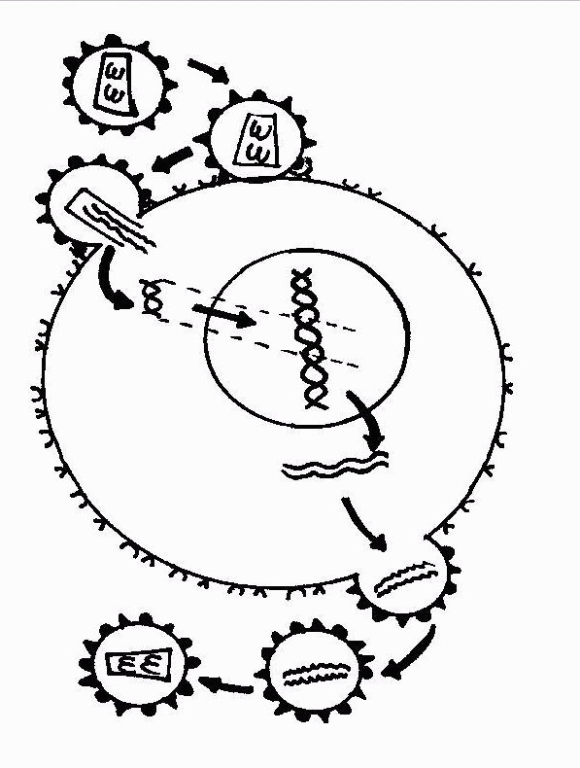
HIV LIFE CYCLE
1 Free virus

2 Binding: Virus binds to cell at two receptor sites.
3 Infection: Virus penetrates cell.
Contents emptied into cell. CD4 Receptors

CCKR5 Receptors

HIV RNA
4 Reverse Transcription:
Single strands of viral RNA are HIV DNA
converted into double-stranded DNA
by the reverse transcriptase
enzyme.
Human DNA

5 Integration: Viral DNA is HIV DNA
combined with the cell’s own
DNA by the integrase enzyme. Human DNA

6 Transcription: When the
infected cell divides, the viral
DNA is “read” and long chains
of proteins are made.

7 Assembly: Sets of viral protein
chains come together.
8 Budding: Immature virus pushes out of the cell, taking some cell membrane with it.

9 Immature virus breaks free of the infected cell.

10 Maturation: The protein chains in the new viral particle
are cut by the protease enzyme into individual proteins
that combine to make a working virus.

Revised March 12, 1997

